Feedback from an Eye Clinic Appointment

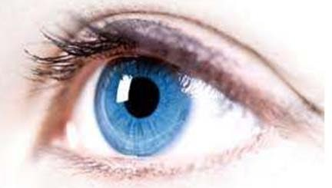
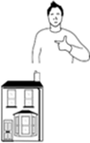
Name of person attending

Address

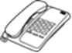
Telephone
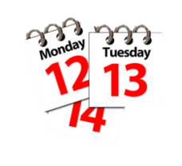
Date of appointment

Feedback from an Eye Clinic Appointment
easy read form

Name and role of supporter at the appointment

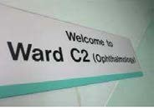
Take this form to the eye clinic appointment

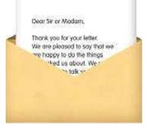
Remember to take the person’s appointment letter. It is a good idea to ask the person’s GP to send the person who is attending the clinic a copy of the GP’s letter to the Eye Doctor

SeeAbility is the operating name of The Royal School for the Blind founded in 1799. Registered Charity Number 255913 © SeeAbility 2017. No part of this document can be altered or changed without permission

Page 1

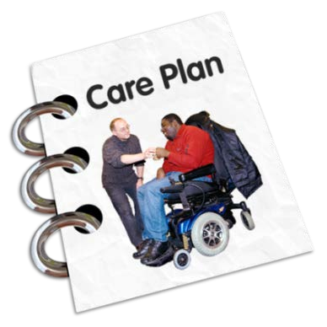
Remember to take the person’s Health Action Plan, information about medication and other medical information

We advise taking notes whilst you are at the meeting. Show the eye doctor this form. You can use this form to help you ask questions at the appointment

Write down information about what was said about the person’s eyes or vision (such as the name of any eye condition, how it affects the person’s eye sight, whether it will be painful for the person, if it will get worse or stay the same)

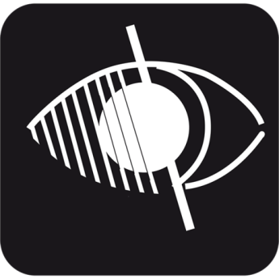
Write down whether the person could be registered as partially sighted (you may hear this being called ‘sight impaired’) or blind (you might hear this being called ‘severely sight impaired’). Who will organise the registration?

SeeAbility is the operating name of The Royal School for the Blind founded in 1799. Registered Charity Number 255913 © SeeAbility 2017. No part of this document can be altered or changed without permission

Page 2

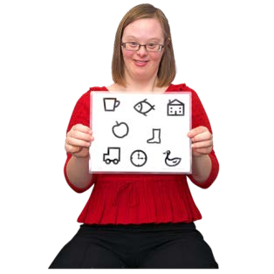
Write down any advice the person might be given about looking after their eyes (such as eye tests and wearing glasses, cleaning their eye lashes, bathing the eye or taking eye drops)

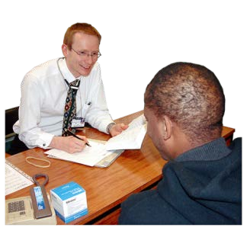

Write the details of other medical professionals the person may be referred to

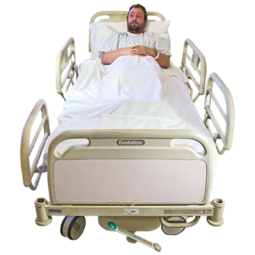
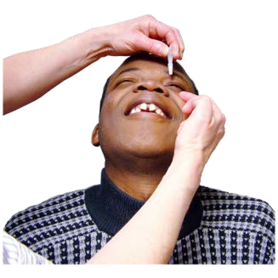
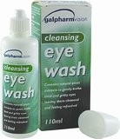
Write down the treatment that is recommended

SeeAbility is the operating name of The Royal School for the Blind founded in 1799. Registered Charity Number 255913 © SeeAbility 2017. No part of this document can be altered or changed without permission

Page 3

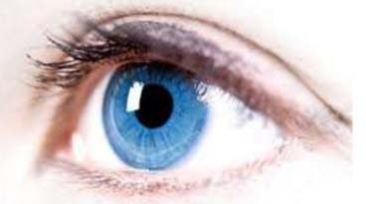
Write down why the treatment is needed Is there a reason why the person cannot have the treatment at the moment?

Write down who else might need to be involved in agreeing to treatment

Write down the risks and benefits of having the treatment

SeeAbility is the operating name of The Royal School for the Blind founded in 1799. Registered Charity Number 255913 © SeeAbility 2017. No part of this document can be altered or changed without permission

Page 4

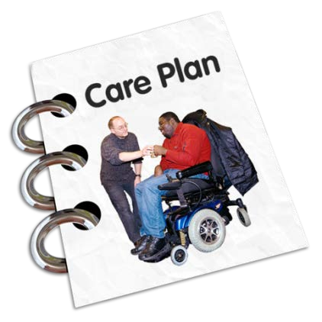
Write down the support that will be needed before, during and after the treatment.
If necessary download the Eye Surgery Support Plan from www.seeability.org

Write down when you and the person need to contact the eye clinic again about
the treatment

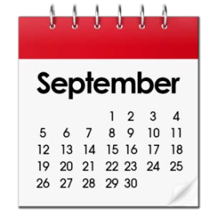
Some clinics only give you a few days to decide if you want to go ahead with the suggested treatment (for example: you might only be given a week or so to decide if you want to go on a cataract operation waiting list )

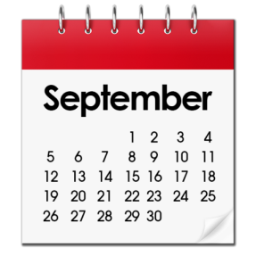
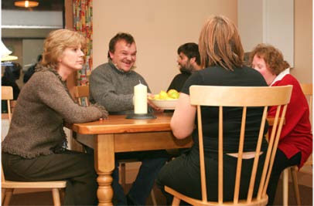
Date and time of the next appointment Who is it with and where? Will a letter be sent out? What will need to be planned between now and the next appointment?

SeeAbility is the operating name of The Royal School for the Blind founded in 1799. Registered Charity Number 255913 © SeeAbility 2017. No part of this document can be altered or changed without permission

Ask at the eye clinic if there is an Eye Clinic Liaison Officer (ECLO) to speak to. An ECLO can give you information about eye problems and procedures. An ECLO can answer questions you might have about your eye clinic appointment

You might also want to talk to a Community Learning Disability Nurse, an Acute Liaison Nurse or someone from the hospital PALS (Patient Advice and Liaison Service)

For more information about eye care and eye health for people with learning disabilities go to www.seeability.org

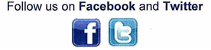
www.seeability.org

Reviewed: March 2018

SeeAbility is the operating name of The Royal School for the Blind founded in 1799. Registered Charity Number 255913 © SeeAbility 2017. No part of this document can be altered or changed without permission

