**Information about my sight**

**Vision Passport**



**Form**

**Please fill in my Vision Passport and share it with those who support me. It will help you understand me and how you should support me**

**Part 1**

My name is

Please call me

This profile was written with me on (date)

Please review this profile with me after 6 months (planned date)

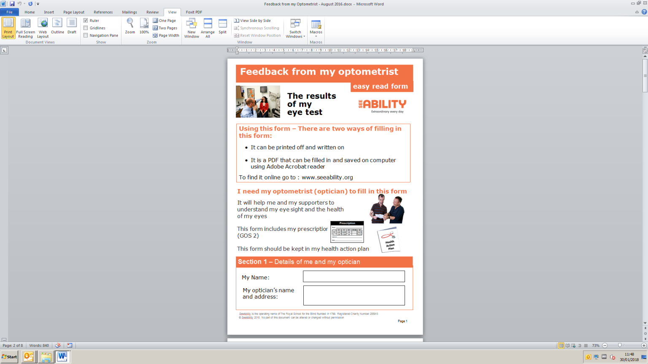**About My Eye Tests – everyone should   
have an eye test every 2 years or more   
often**

My most recent eye test was on (date)

My next eye test is due on (date)

For results of my last eye test please read my

“Feedback from my Optometrist” form.

You can get a copy from:

[www.seeability.org/feedback-optom](http://www.seeability.org/feedback-optom)

**About Glasses – 6 out of 10 adults with learning  
disabilities need to wear glasses and often need to support to do this**

I have a pair of glasses for looking at things near   
to me yes no

I have a pair of glasses for looking at things further away   
from me.

yes no

I have a pair of glasses for looking at things both near   
and far away. yes no

I should wear glasses but don’t wear them yes no

**About My Vision – adults with learning disabilities are 10 times more likely than others to have serious sight problems**

I have sight loss that glasses cannot correct yes no

**If you have sight loss, complete Part 2:**

**Part 2**

My sight loss is caused by

It affects my vision in the   
following ways

Please help me to use my   
vision by

I have had sight loss since I was (age)

**When you want my attention (communication)**

I prefer you to say hello by

If I want to finish an activity   
or say goodbye, I will

When I want your attention   
I will

Sometimes I can find it difficult to hear clearly. yes no

Please help me to use my   
hearing by

**Things that help me:**

I have my belongings arranged so I can find them. Here are some of the most important things I want to have kept in the same place:

This is the equipment I use and what I use it for

**Some things I do not like**

Environments / situations that I find difficult / stressful

I don’t like it when

If I am not happy with something that is happening I may

**Finding my way around**

I can find my way around the following places on my own

You can help me to do this by

I need your help when we go to

I like you to do the following things when you are being my sighted guide

When I am being guided, I can get anxious or upset when

You can find out more about how to support me in these documents

Image result for free website icon

[**www.seeability.org**](http://www.seeability.org)

Facebook: Facebook.com/RSB.seeability

Twitter: @seeability

Youtube: [www.youtube.com/SeeAbilityFilms](http://www.youtube.com/SeeAbilityFilms)

[eyecare@seeability.org](mailto:eyecare@seeability.org)

01372 755000











SeeAbility is the operating name of the Royal School for the Blind founded in 1799. Registered charity number 255913. ©SeeAbility 2019. No part of this document can be altered without permission.

Reviewed: April 2019